**Assignment -1**

**Python Programming**

|  |  |
| --- | --- |
| Assignment Date | 19 September 2022 |
| Student Name | Bhuvanesh B |
| Student Roll Number | CITC2007202 |
| Maximum Marks | 2 Marks |

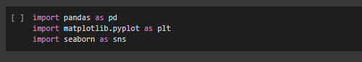

## Question-1: Load the Dataset

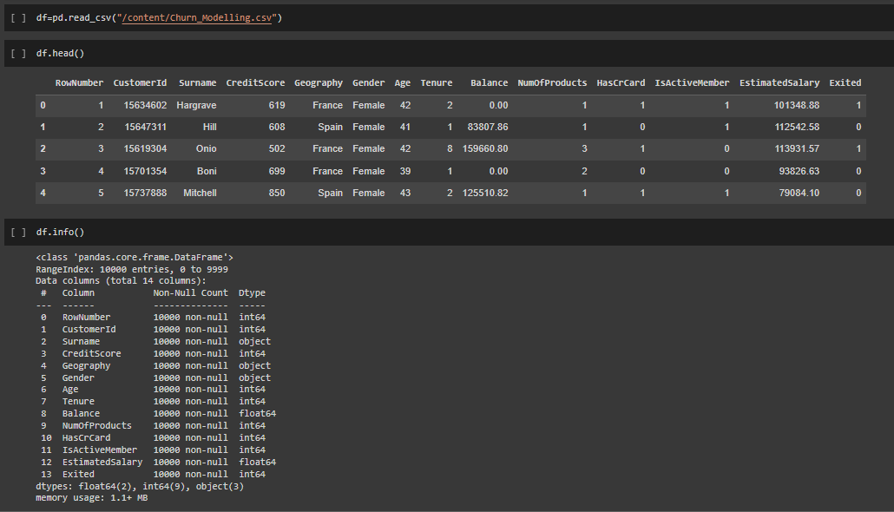

## Question-2: Visualization

import seaborn as sns

## 

## 

## 

## Question-3: Descriptive Statistics

## 

## 

## 

## 

## 

## 

## Question-4: Handling the missing values

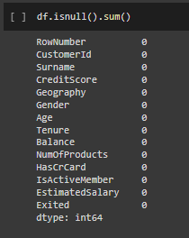

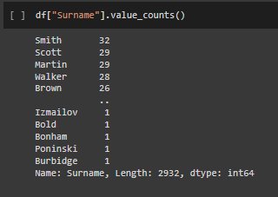

## Question-5: Find the outliers and relace the outliers

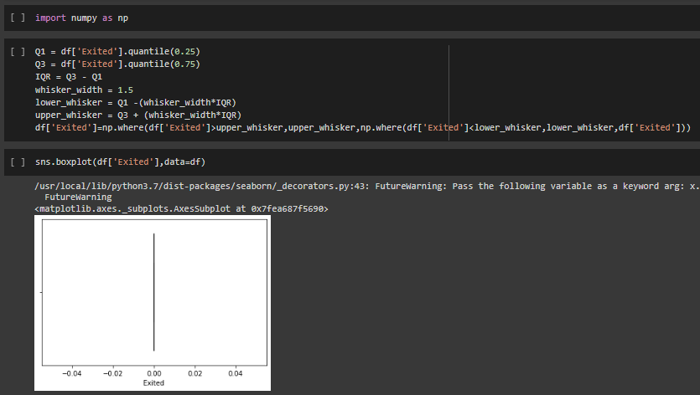

## Question-6: Check for Categorical columns and perform encoding.

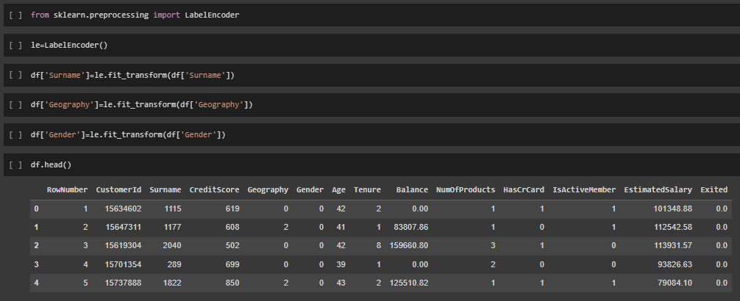

## Question-7: Split Data (Dependent and Independent)

## 

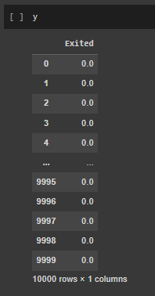

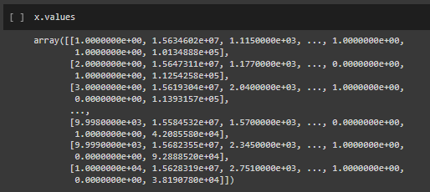

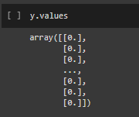

## Question-8: Scale the independent values

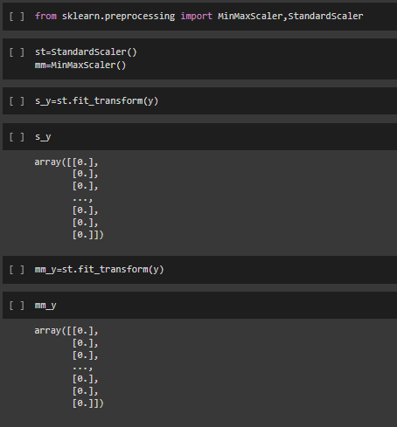

## Question-9: Splitting test and train data

## 